Guided Capstone Project Report

Big Mountain Resort Better Ticket Price Analysis and Modelling

By A. Karadsheh

Estimating a better ticket price is a challenge without modern computing tools such as machine learning. Estimation of ticket prices based on averages of regional or industry prices leaves a lot to be desired to optimize the decision making. While a process of analysis of the price using machine learning is more involved initially, it can simplify the decision making in the long run.

An initial machine learning model was designed to assess potential ticket price increases to cover the operational cost of the additional ski lift ($1,540,000) for the upcoming season. Some business assumptions were taken into considerations: 350,000 visitors for the season, with an average of 5 days stays and 5 tickets per visitor. Additional assessments included :

1) Closing up to 10 least used runs

2) Adding a run, increasing the vertical drop by 150 feet, and installing an additional chair lift.

3) Adding 2 acres of snow making in addition to adding a run, increasing the vertical drop by 150 feet, and installing an additional chair lift.

4) Increasing the longest run by .2 miles and guaranteeing its snow coverage by adding 4 acres of snow making capability.

The baseline information has the current adult ticket price for weekdays and weekend as currently $81, the average ticket weekend price for Montana ski resorts as $52 and the average for all resorts with data in our dataset as $64 +/- $24.55.

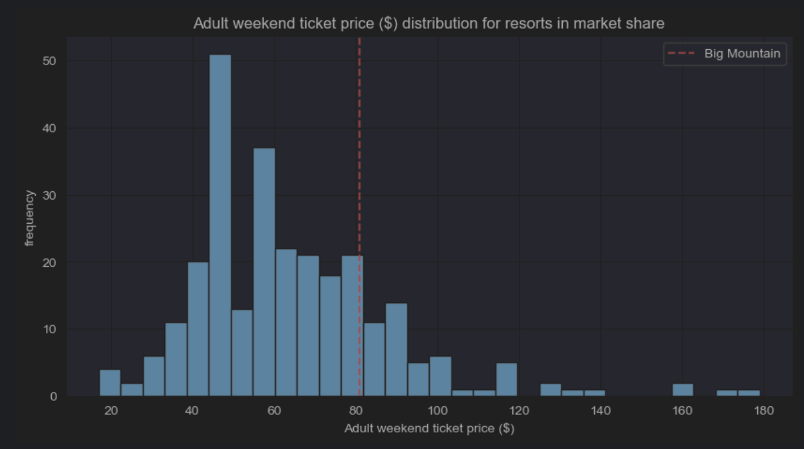

Figure 1. Adult weekend ticket price for Big Mountain Resort is highlighted in red, and is in the higher range of ticket prices.

Features correlations with ticket prices were analyzed offering possible support to increasing the adult ticket prices. The best eight features included in the analysis were: The vertical drop, the snow making acreage, the number of total chairs, the number of fast quads, the number of runs, the longest run distance, the number of trams and the total skiable terrain acreage. The latter two had negative coefficients. Four features were deemed the most prominent in relationship to the ticket price: The number of fastquads lifts, the number of runs, snow making acreage and the vertical mountain drop height.

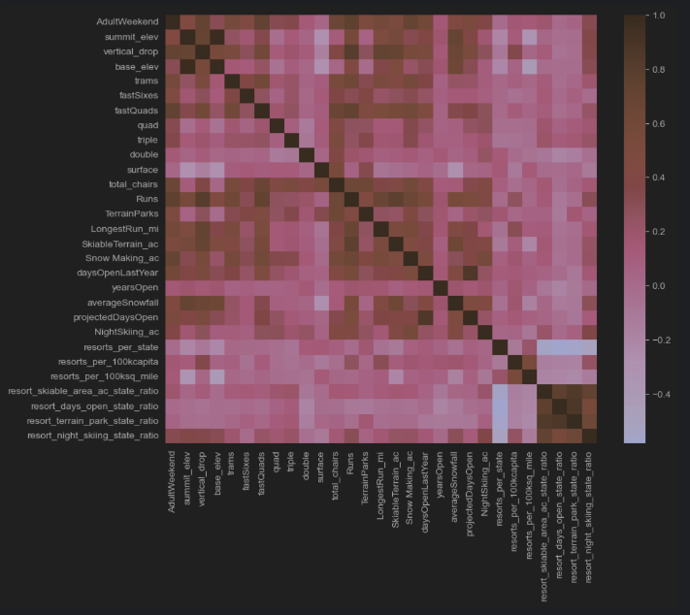

Figure 2. A heat map representation of correlations between the adult weekend ticket price and all the features in the dataset.

An example of positive feature to consider for lifting the price is the fast quad. This feature places Big Mountain Resort in top few resorts offering it. This feature warrants further analysis as to its importance to visitors and correlated highly with higher prices.

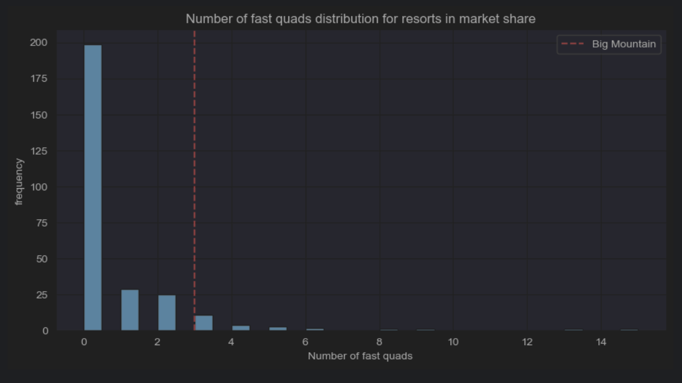

Figure 3. Big Mountain Resort has 3 fast quads placing it in the higher echelon of skiing resorts.

Similarly, other analyses that were run gleaned other insights that have significant correlations with the ticket prices. A more detailed discussion is beyond the scope of this summary.

Summary of findings:

Big Mountain Resort has many offerings and features that lend support to a higher price. The model predicts a price of $96 +/- 15, leaving ample room for improvement, with or without further scenarios. The maximal price support of $96, may generate a seasonal revenue of $26, 250,000.

For scenario 1, closing up to 10 runs, the model showed reducing 1-2 runs, decreases support for the current ticket price. Closing 3-5 runs, does not contribute greatly to further decline in ticket price support. Closing more will have a more pronounced effect.

For scenario 2, adding a run, increasing the vertical drop by 150 feet, and installing/operating an additional chair lift, the model suggested increased ticket price support by $1.99 amounting to $3,474,638 increased cash flow.

For scenario 3, adding 2 acres of snow making, in addition to scenario 2 changes, increased the ticket price support by $1.99 amounting to $3,474,638 increased cash flow.

For scenario 4, increasing the longest run by .2 miles, the model found $0.0 support for increases in ticket price.

Other preparatory analyses were made and are beyond the scope of this summary.

Conclusions:

The added operating cost of the new chairlift, $1,540,000 per season may be offset by implementing scenarios 2 or 3, each generating $3,474,638 in improved cash flow. With 1,750,000 tickets per season assumed, scenario 1 would correlate with a worsening of ticket price support amounting to $1,225,000, assuming a decrease of $0.7 in ticket price support. These 3 scenarios may be combined to varying degrees to achieve the optimal cash flow for the season. The first scenario may be done incrementally over time with monitoring of visitor volume response over time.

The development of a machine learning web app, with a dashboard that allows dynamic changes of several of the features and variables with visualization of the outputs may be helpful to management in studying many more scenarios and combinations. Future monitoring of outcomes may be possible of the outputs that could include ticket price predictions, improvements in cash flow and operating expenses.